**Project Title:**

**Crime Reporting and SOS Emergency Service App**

**Introduction:**

In today's world, personal and public safety are critical concerns. The **Crime Reporting and Emergency Service App** is a mobile application designed to assist users in reporting crimes, emergencies, or suspicious activities directly to authorities, and to quickly trigger an SOS in dangerous situations. This system bridges the gap between citizens and law enforcement agencies, making communication faster, safer, and more efficient.

**Objective:**

* To enable users to **report crimes and emergencies** instantly from their mobile phones.
* To provide **SOS functionality** that sends immediate alerts to emergency contacts and nearest authorities.
* To track location-based incidents and provide assistance faster.

**Tools & Technologies Used:**

| **Component** | **Tool/Technology** |
| --- | --- |
| Frontend (App Interface): | HTML,CSS,JavaScript |
| Backend | :firebase |
| Database | :Firebase Firestore |
|  |  |
|  |  |
| Authentication | :Firebase Auth |
| Emulator | :For testing and previewing the app |
| diagram | :Canva |

**Key Features:**

* 🆘 **Emergency contact number** – Sends location and message to emergency contacts.
* 📸 **Crime Reporting** – Upload photo/video and describe the incident.
* 🔔 **Push Notifications** – Instant alerts from police or local authorities.
* 📂 **Report History** – Track previously reported incidents.
* 🔐 **Secure Login** – Authentication using phone/email.
* 🗺️ **Nearby Help Centers** – View police stations and hospitals on the map.

**Flow Chart:**

Here is the flow chart that illustrates how the app functions:

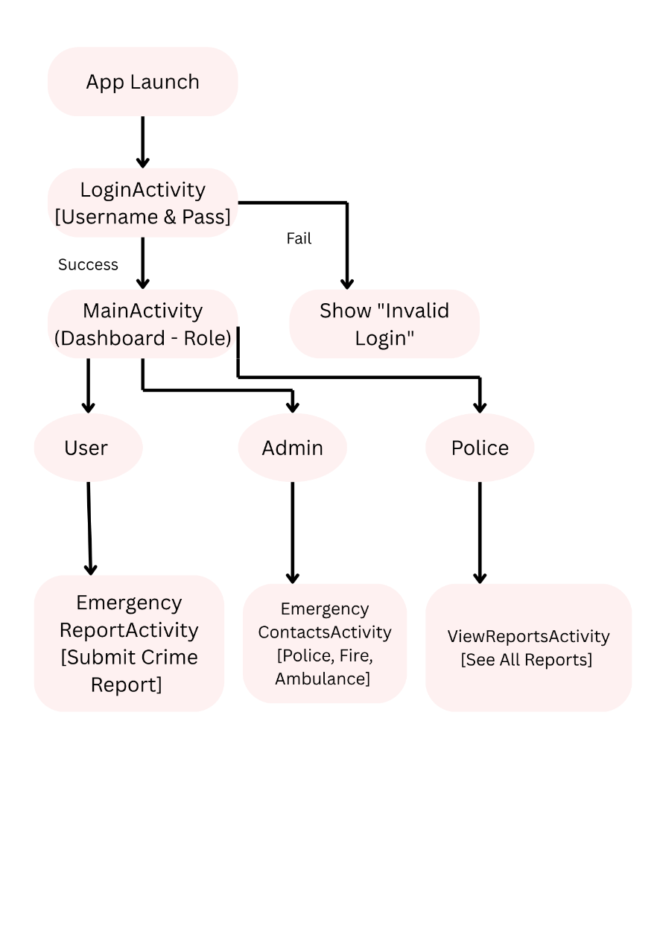

Security and Privacy

* End-to-end encryption for all reports.
* Users can control what data is shared.
* Authentication is required to prevent misuse.

**Benefits:**

* Encourages **citizen participation** in safety.
* **Faster response** to emergencies.
* **Data collection** for crime analysis.
* Helps build a **safer community**.

**Future Enhancements:**

* AI-powered threat detection using camera feed.
* Integration with local CCTV networks.
* Voice-activated SOS.
* Multilingual support.
* Anonymous reporting option.

**Conclusion:**

This app can play a critical role in **public safety** by enabling faster crime reporting and instant SOS alerts. By integrating modern technologies like **real-time location tracking**, **mobile notifications**, and **cloud-based data storage**, the application creates a reliable bridge between citizens and law enforcement agencies.

Top of Form

Bottom of Form